**Minha Cuca**

Currently in Brazil there is not a single platform of clinical data of the patient, that is, with each new care in different institutions it is necessary for the patient to tell all his history and present all the exams.

In some cases, patients are accompanied by family members who assist them in understanding the medical positioning. However, some patients do not have this care and do not even know the medical protocols or validity of the exams performed previously.

Our platform aims to grant the patient all his history of consultations, allowing that through authorization, all the network of doctors, laboratories and hospitals that are attended have access to previous appointments.

In addition, it would allow doctors to gain agility in fulfilling evolution through voice command. For project monetization, after patient approval, we would allow API integration with our platform and the system that physicians currently use.

For this hackathon and MVP, Hackmon delivered the platform thinking about elective queries and voice command through whatsapp.

Below is the simple stream of interaction for audio capture:

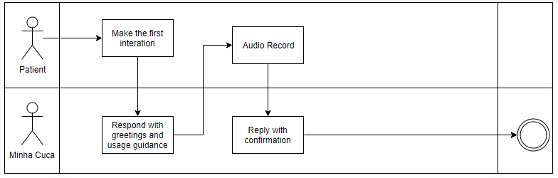

And below, the flow for authorization to access the history of Minha Cuca:

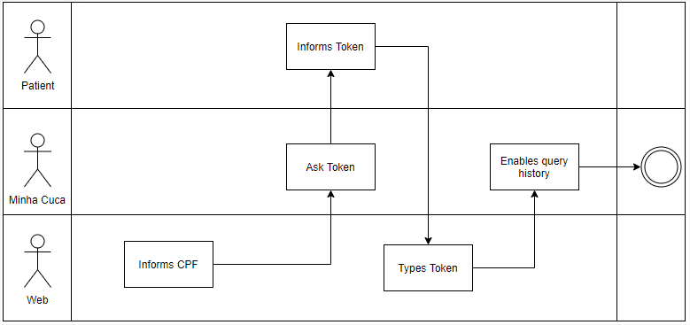

Hackmom mapped out as an opportunity to improve and roadmap the project:

• Structure the medical anamnesis for the evolution of an Electronic Record

• Expand the tool for other types of care

• Allow other forms of audio capture, for example through telemedicine platforms

• Dashboard of the specialties most used by the patient

• Integration with legacy medical systems

• Recording and image identification of exams and reports